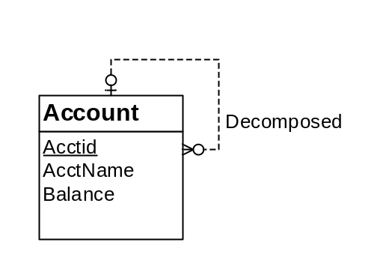
Figure 2: ERD for Conversion Problem 5

- Account (PRIMARY KEY (AcctID), DecAcctID, AcctName, Balance)
FOREIGN KEY (DecAcctID) REFERENCES Account
Conversion Rule:
- Use entity type rule to convert Account entity
- Use 1-M relationship rule to incorporate the 1-M Decomposed relationship. Add a column for Decomposed Account and indicate it as FK referencing to Account table.

